**Timing diagram of INR M**

* Last Updated : 26 Oct, 2018

**Problem –** Draw the timing diagram of the given instruction in 8085,

INR M

The content present in the designated register/memory location (M) is incremented by 1 and the result is stored in the same place. If the operand is a memory location, it is specified by the contents of HL pair.  
**Example:**

Attention reader! Don’t stop learning now. Get hold of all the important CS Theory concepts for SDE interviews with the [**CS Theory Course**](https://practice.geeksforgeeks.org/courses/SDE-theory?vC=1) at a student-friendly price and become industry ready.

INR M

Opcode: INR

Operand: M

M is the memory location (say 5000H) and suppose the data present at M (or 5000H) is 26H, which is need to be incremented by 1. Hex code- 34H

**Algorithm –**  
The instruction INR M is of 1 byte; therefore the complete instruction will be stored in a single memory address.  
For example:

2000: INR M

The opcode fetch will be same as for other instructions in first 4 T states.  
Only the Memory read and Memory Write need to be added in the successive T states.  
For the opcode fetch the IO/M (low active) = 0, S1 = 1 and S0 = 1.  
For the memory read the IO/M (low active) = 0, S1 = 1 and S0 = 0. Also, only 3 T states will be required.  
For the memory write the IO/M (low active) = 0, S1 = 0 and S0 = 1 and 3 T states will be required.

The timing diagram of INR M instruction is shown below:

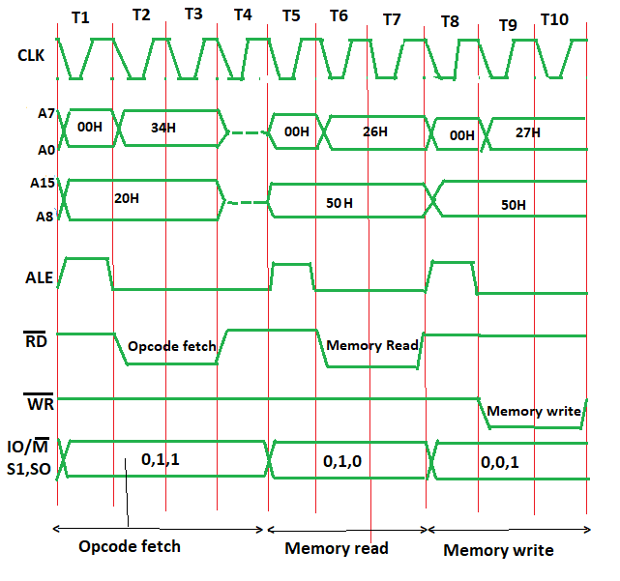

**In Opcode fetch ( t1-t4 T states ) –**

* **00:** lower bit of address where opcode is stored, i.e., 00
* **20:** higher bit of address where opcode is stored, i.e., 20.
* **ALE:** provides signal for multiplexed address and data bus. Only in t1 it used as address bus to fetch lower bit of address otherwise it will be used as data bus.
* **RD (low active):** signal is 1 in t1 & t4 as no data is read by microprocessor. Signal is 0 in t2 & t3 because here the data is read by microprocessor.
* **WR (low active):** Signal is 1 throughout, no data is written by microprocessor.
* **IO/M (low active):** Signal is 0 in throughout because the operation is performing on memory.
* **S0 and S1:** both are 1 in case of opcode fetching.

**In Memory read ( t5-t7 T states ) –**

* **00:** lower bit of address where opcode is stored, i.e, 00
* **50:** higher bit of address where opcode is stored, i.e, 50.
* **ALE:** provides signal for multiplexed address and data bus. Only in t5 it used as address bus to fetch lower bit of address otherwise it will be used as data bus.
* **RD (low active):** signal is 1 in t5, no data is read by microprocessor. Signal is 0 in t6 & t7, data is read by microprocessor.
* **WR (low active):** signal is 1 throughout, no data is written by microprocessor.
* **IO/M (low active):** signal is 0 in throughout, operation is performing on memory.
* S0 and S1 – S1=1 and S0=0 for Read operation.

**In Memory write ( t8-t10 T states ) –**

* **00:** lower bit of address where opcode is stored, i.e, 00
* **50:** higher bit of address where opcode is stored, i.e, 50.
* **ALE:** provides signal for multiplexed address and data bus. Only in t8 it used as address bus to fetch lower bit of address otherwise it will be used as data bus.
* **RD (low active):** signal is 1 throughout, no data is read by microprocessor.
* **WR (low active):** signal is 1 in t8, no data is written by microprocessor. Signal is 0 in t9 & t10, data is written by microprocessor.
* **IO/M (low active):** signal is 0 in throughout, operation is performing on memory.
* S0 and S1 – S1=0 and S0=1 for write operation.